ACIP Meeting, Aug 26, 2020

Virtual

Draft minutes by Stan Grogg, DO

American Osteopathic Association’s Liaison Member

**Coronavirus Disease 2019 (COVID-19) Vaccines**

**Introduction:**

At least **200 candidate** vaccines are in the preclinical or clinical stage of development, including 4 candidate vaccines currently in clinical trials in the United States.

Ensuring that COVID-19 vaccines are safe and effective, as well as appropriately allocated and implemented, will be critical for the prevention of disease and reducing the effects of disease on society.

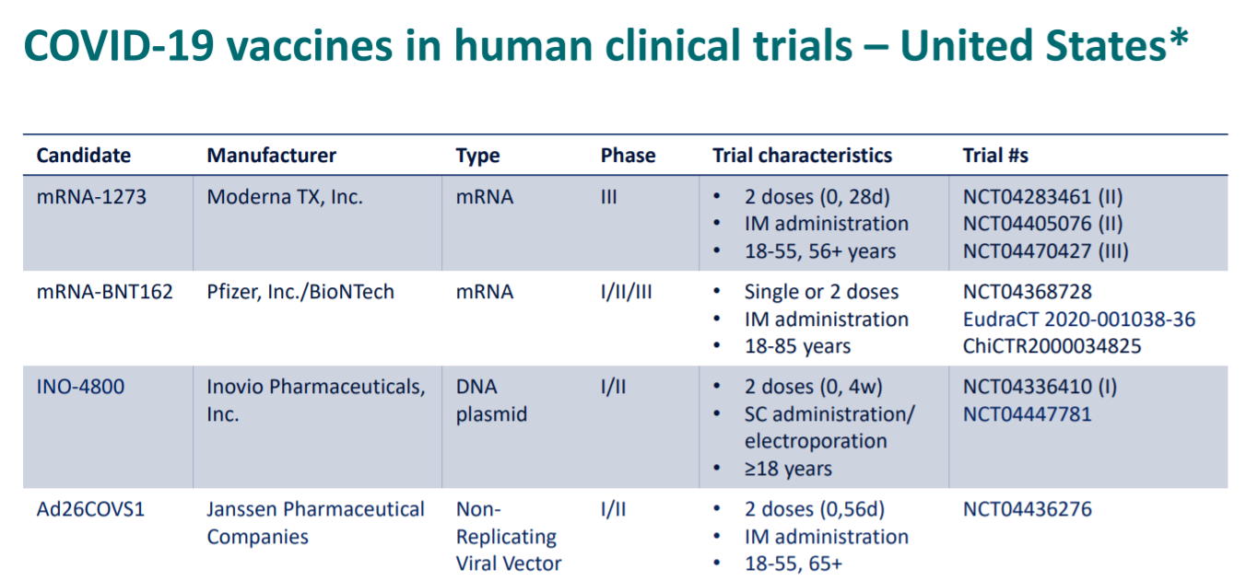

**Summary of two vaccine candidates currently in clinical trials**

1. mRNA-1273 by Moderna: encodes for the full-length spike protein, robust neutralizing antibody response in mice and non-human primates
   1. No indication of enhanced respiratory disease after viral challenge
   2. 100 mcg two-dose series seroconverted all participants
   3. Well tolerated in all age groups. Tenderness at injection site most common adverse reaction, especially after 2nd dose.
   4. Plan to do further evaluation in pediatrics, pregnancy, and immune deficiencies.
2. Pfizer/BioNTech mRNA
   1. Two clinical studies assessed the safety, tolerably, and immunogenicity of ascending dose levels (US 1/2/3 study and Germany 1/2 study)
   2. Based on the totality of data, Pfizer chose to advance BNT162b2 at 30 ug dose levels
   3. Pain at injection site most common side effect for 18-55 years and 65-85 years.
   4. Other symptoms included fever, fatigue, headache, chills, vomiting/diarrhea, muscle pain and joint pains but no serious side effects were found.
   5. A robust SARS-CoV-2 50% neutralization titers after 2 doses
   6. BNT16b1 induces a strong CD4+ and CD8+ cell Reponses with Th1 dominance in German trial
   7. Phase 1 demonstrated encouraging safety & immunogenicity for BNT162b2, supporting advancement to Phase 2/4
   8. Robust SARS-CoV-2 neutralization titers after 2 doses of BNT162b2 in Phase 1 exceed those in human convalescent panel (HCS)
   9. Phase 2/3 started July 22, 2020
   10. One problem is needed to keep at specific temperature and thus special unit.
   11. CDC is working on the refrigeration of the vaccine to hopefully by-pass the need for a separate unit
   12. The Pfizer vaccine is enrolling 19% African American and 4% Hispanic.
3. Safety of vaccines: several agencies follow vaccinations for safety such as VEARS, CDC’s clinical immunization safety assessment (CISA) project, Vaccine data safety datalink (VDS), as well as state and local reporting agencies and many others. Current monitoring systems are in place to monitor the safety of COVID-19 vaccines.
4. Epidemiology:23, 5,682,491 documented cases of Coronavirus infection and 176, 223 death in the US as of Aug 23, 2020. The following chart indicates the high risk underlying medical conditions according to age:

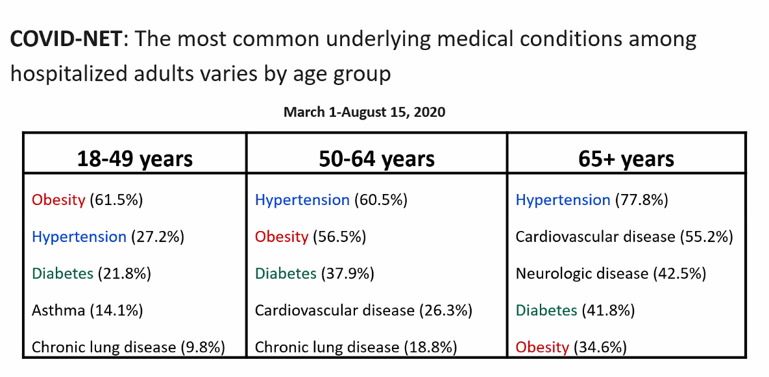

1. Prioritizing the COVID Vaccine when available: below is the present possible situation, but not finalized. 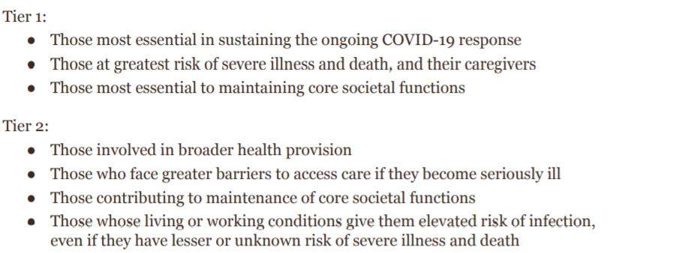

Next 2020 ACIP Virtual Meeting Dates (tentative)

September 22, 2020

October 28-29, 2020